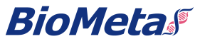
10F.9G2-ratIgG2b
Cat. No.

Product information
Isotype: | ratIgG2b
Source: | CHO-K1
Extinction Coefficient: | 1.355
AA MW: | 145kD
Concentration: | lot specific
Purity: | >95% determined by SDS-PAGE  >95% determined by SEC-HPLC
Endotoxin Level: | <1EU/mg determined by LAL method
Sterility: | 0.2µM filtered

Formulation and Storage
Formulation: | PBS, pH 7.4
Storage and handling: | Store at -80ºC. Avoid multiple freeze-thaw cycles.

Assay Data

SDS-PAGE

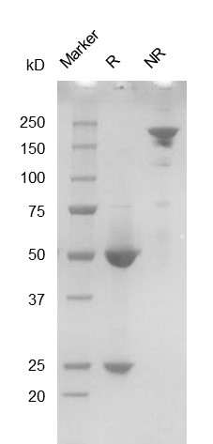

SEC-HPLC

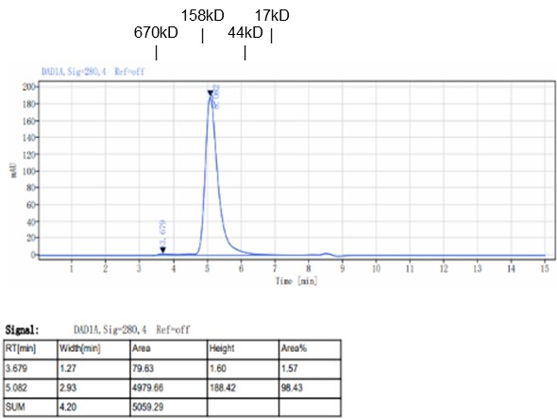
- For Research Use Only. Not for use in diagnostic procedures.

Bioactivity

